Task01.Clone the project repository

Repository folder structure

1.File name: final_ project 101

2.Folder name: 1.folder_structure.png

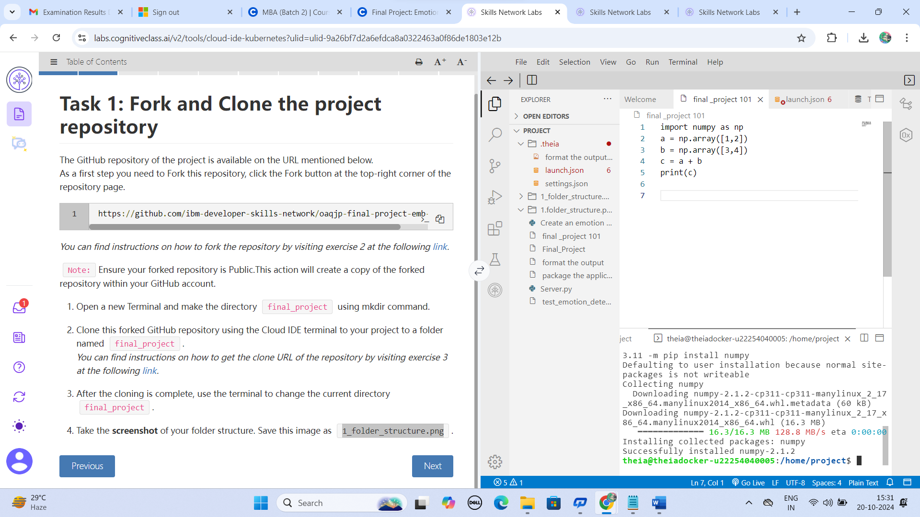

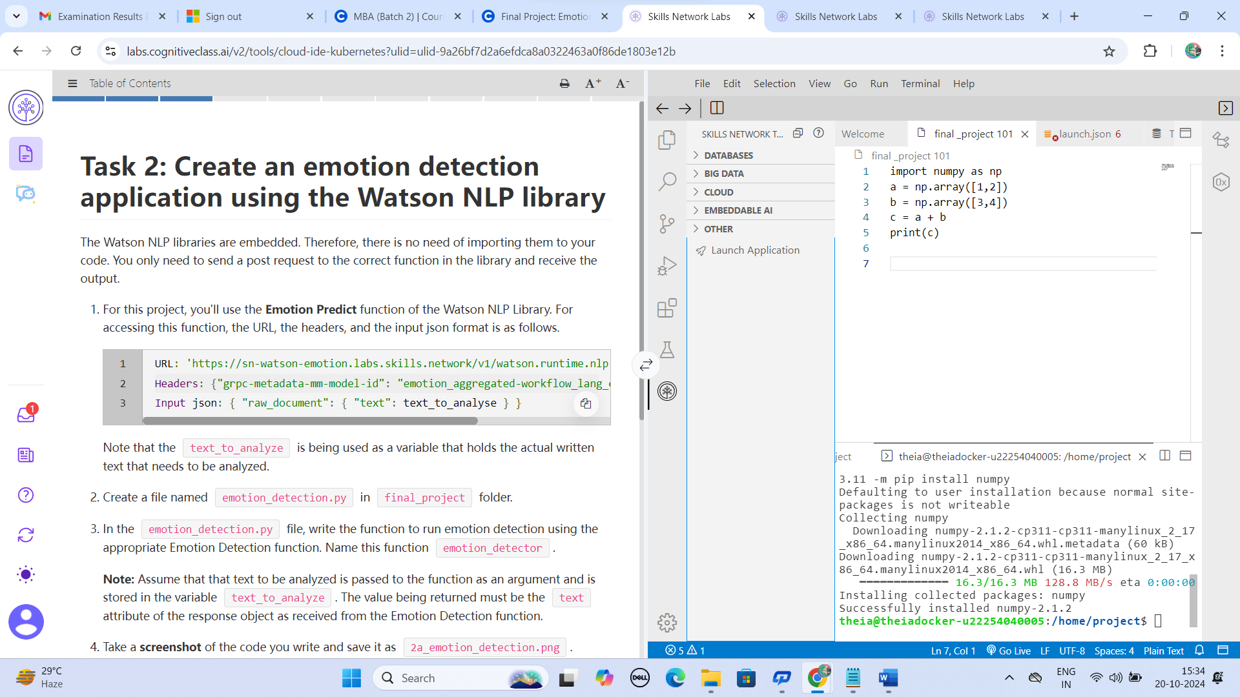

**Terminal: packages**

python3.11 –version

Python 3.11.2

python3.11 -m pip install numpy